DORM ROOMS TO BOARDROOMS new nonfiction trade
VICTORIA PILATE, Ph.D.

"...Insightful. Brought forth issues and concepts that every college student should understand as they prepare for graduation. It is a great read for college students who all eventually enter the world of work. "
---Hazel O'Leary, Ph.D., President of Fisk University
"Dorm Rooms to Boardrooms provides a wealth of useful pointers about issues, from the mundane to the vital, which can be advantageous for college students to consider when entering the 'real world'. A helpful, easy read for students, advisors, and employers alike."
---Angela N. Romans, Associate Director of Admission and Director of Minority Recruitment at Brown University

In Dorm Rooms to Boardrooms (Crandell & Rose; $13) Victoria Pilate guides readers though the pain of transitioning from college to the Real World. The book starts with the job search process and continues on through relocating and the first days on the job. Its major sections are on surviving office politics and learning professional etiquette and grooming. The book covers all major hurdles of starting a job and making career decisions. Dorm Rooms to Boardrooms offers valuable tips on travel and business presentations.

Woven throughout Dorm Rooms to Boardrooms is Victoria Pilate’s own story as well as that of 200-odd survey respondents. The author also brings in academic research to drive home points. Whether the reader is a college underclassman or a recent graduate, Dorm Rooms to Boardrooms provides an exceptional read with valuable advice. The book is beneficial even for those already in the workforce who are struggling to decipher the unspoken rules of the office. Victoria Pilate offers readers sage advice on surviving the rough waters of transitioning to the Real World.

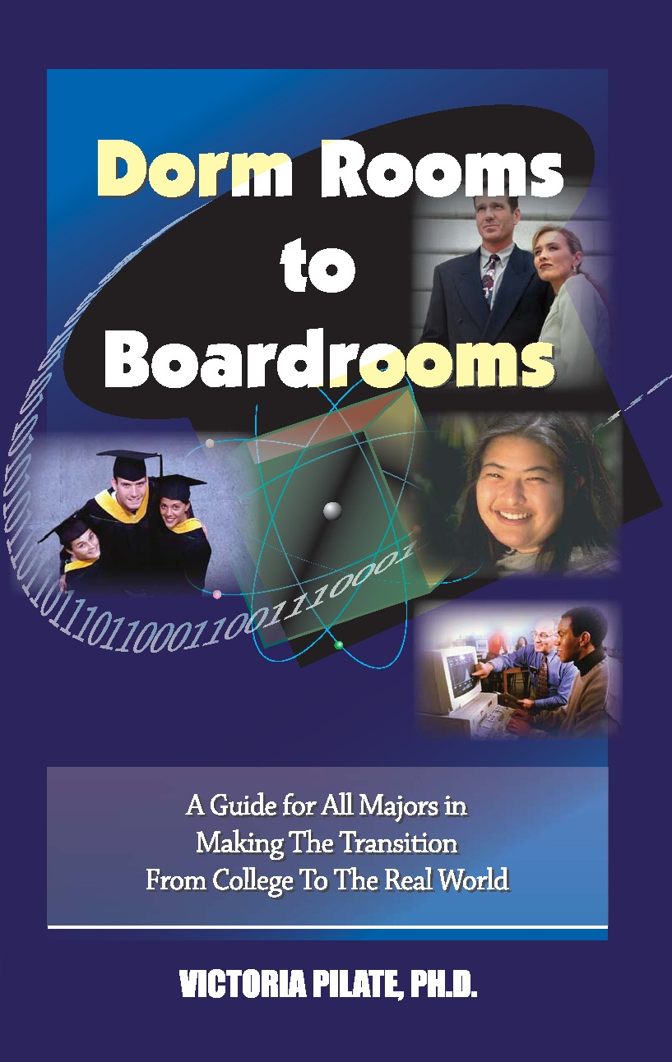
NONFICTION
320 pages, 5 ½ x 8 ½
ISBN: 0-9759665-0-2
$13 TRADE PAPERBACK

- ADVANCE READING COPY PROMOTION

- ONLINE MARKETING CAMPAIGN

- AUTHOR BOOK TOUR

- NATIONAL PRINT PUBLICITY

- NATIONAL ADVERTISING
Victoria Pilate is a researcher and former statistician and economist with the federal government. Pilate earned undergraduate degrees in economics and business administration (magna cum laude) from Florida A&M University. Pilate completed a master's degree in economics from Howard University in 1992. She holds a Ph.D. from the University of Maryland, Baltimore County. In late 2005, she was named by the University of Maryland Baltimore County as an outstanding alumnus. Dorm Rooms to Boardrooms is her first career book.
