Talking with…
Victoria Pilate, author of  Dorm Rooms to Boardrooms | 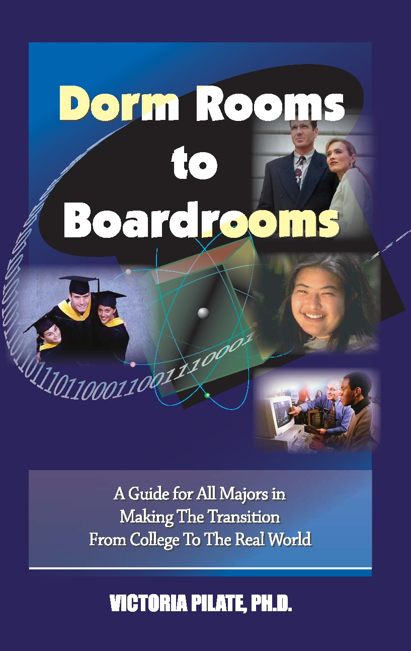

Praise for the Advanced Copy of Dorm Rooms to Boardrooms  “An excellent career resource and planning guide. Valuable information.”  ---William R. Harvey, Ph.D., President of Hampton University  "The book touches on things that are only learned through having experienced outcomes of real life situations."  ---Willie H. Thomas, Ph.D., Director of the Division of Continued Education and Community Service at Alabama State University  "The book promises clarity, wisdom, and common sense."  ---Sebetha Jenkins, Ph.D., President of Jarvis Christian College  "Part of the beauty of 'Dorm Rooms' is that Pilate takes nothing for granted as she addresses her readers."  ---The North Brevard Beacon  “Her insight, common sense, and creativity are superb. Her issues are informative, realistic, and relevant. ‘Dorm Rooms to Boardrooms’ is a must-have.”  --Abolite Independent | Why did you switch careers and become a writer? It was time for a career change and a lifestyle change. I had wanted to be a writer since I was young, though I admit I had envisioned myself as a writer of fiction. When the right time and opportunity presented itself, I leapt.  Some of the stories in the book are very funny. Did you make them up? No. These are my actual experiences and those related to me by people either who answered the survey or whom I interviewed. I also included things my friends or co-workers told me about their jobs and experiences.  So far you’ve received mostly glowing reviews. What’s your reaction? Like anyone in the creative arts, I’m grateful when my work is appreciated. There’s always that unknown factor of how it would be received. I’m particularly grateful for the praise from university presidents. That was unexpected and greatly appreciated.  The book seems to be directed at college graduates. Do you recommend it for others? Yes. In fact, at book signings, most buyers have been older women and parents buying the book for their children. Two universities who bought the book bought it for their freshmen class. The issues in the book of workplace issues can happen anywhere, including work-study jobs, internships, or part-time jobs. Roommate conflicts happen in college dorms or among working professionals. The information on presentations, health, etiquette, and travel is useful for just about anyone.  What’s next? I’m working on the companion books to Dorm Rooms to Boardrooms. First, I’m writing a money management book for the newly independent. I’m also working on a transitions book for new college students. Somewhere along the way, I plan to resume on my research on scholarship applications as well as write some children’s literature.  Where do people get the book? It’s available from my website, victoriapilate.com, and Crandell & Rose’s website (www.crandell-rose.com). It’s better for students to buy it from my website or the Crandell & Rose website because it cost $10 instead of the retail price of $13. It’s also available from Barnes & Nobles, amazon.com, and powells.com. Some Follett campus bookstores also carry it. Some crafty people are selling the advanced copy online as a used book; I don’t recommend students buy those copies because the actual book is nearly 30 pages longer than the advanced copy.
These talking points may be reprinted for publication in their entirety or excerpted as individual questions and answers without prior permission. Permission is granted so long as the questions and answers are reprinted in their entirety. These talking points and other questions and answers are downloadable from the Crandell & Rose website (www.crandell-rose.com). Contact: Michele Baumgartner at info@crandell-rose.com or 301-523-4981.

About VICTORIA PILATE, author of

DORM ROOMS TO BOARDROOMS
(Crandell & Rose, September 2006)

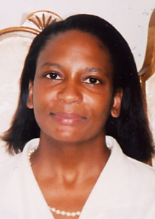

Victoria Pilate was formerly an economist and statistician for the federal government for 15 years. She received recognition from the President's Council on Integrity and Efficiency and the
Executive Council on Integrity and Efficiency in 2004. Today, she is an independent contractor and author.
Victoria grew up in Florida where she attended Florida A&M University. She graduated magna cum laude with a dual degree in economics and business administration. Pilate also has a graduate degree in economics from Howard University and earned a Doctorate in Policy Sciences (Evaluation Policy) from the University of Maryland, Baltimore County. In late 2005, she was named by the University of Maryland Baltimore County an outstanding alumnus.
Victoria’s new book Dorm Rooms to Boardrooms was published by Crandell & Rose in September 2006. Her book is a complete guide to workplace success for the soon-to-be-graduate or the career changer. It’s also essential reading for undergraduates preparing for internships and co-ops. Pilate uses a wealth of real world experiences to highlight issues of entering the workplace and surviving in the real world.
Dorm Rooms to Boardrooms is available from the Crandell & Rose website (www.crandell-rose.com) at a discounted price. It is also available at major bookstore chains and online at www.powells.com, www.amazon.com, and www.banrnesandnoble.com.
Victoria Pilate is a member of the Southeast Association of Colleges and Employers, the Southern Association of College Student Affairs, the UMBC Alumni Association, the Society for Human Resource Management and the Population Association of America. Victoria is active with volunteer work including founding her own foundation, the Torment of Thirst Foundation.
She lives in Maryland.

